**Ideation Phase**

**Brainstorm & Idea Prioritization Template**

|  |  |
| --- | --- |
| Date | 28 June 2025 |
| Team ID | LTVIP2025TMID59203 |
| Project Name | EDUCATIONAL ORGANISATION USING SERVICENOW |
| Maximum Marks |  |

**Brainstorm & Idea Prioritization Template:**  
In an educational organization, brainstorming creates an open and collaborative environment that encourages faculty, administrators, and students to actively engage in creative problem-solving. Leveraging platforms like ServiceNow, teams can log, track, and refine ideas in real time, even when working remotely. Prioritizing volume over immediate value, the process welcomes unconventional thinking and promotes collective development of innovative solutions. With ServiceNow’s integrated workflows, each idea can be categorized, assigned, and monitored through to implementation—ensuring that the best concepts evolve into practical improvements. Use this template during institutional brainstorming sessions to spark imagination and co-create impactful strategies across your campus community.

Step-1: Team Gathering, Collaboration and Select the Problem Statement

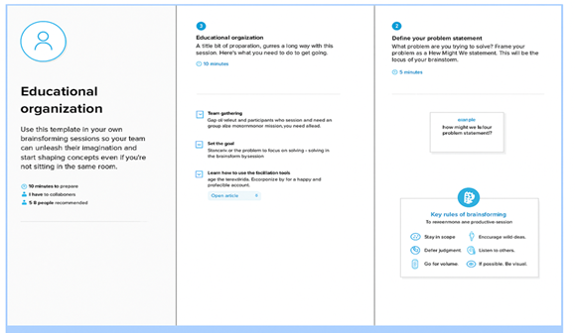

**Step-2: Brainstorm, Idea Listing and Grouping**

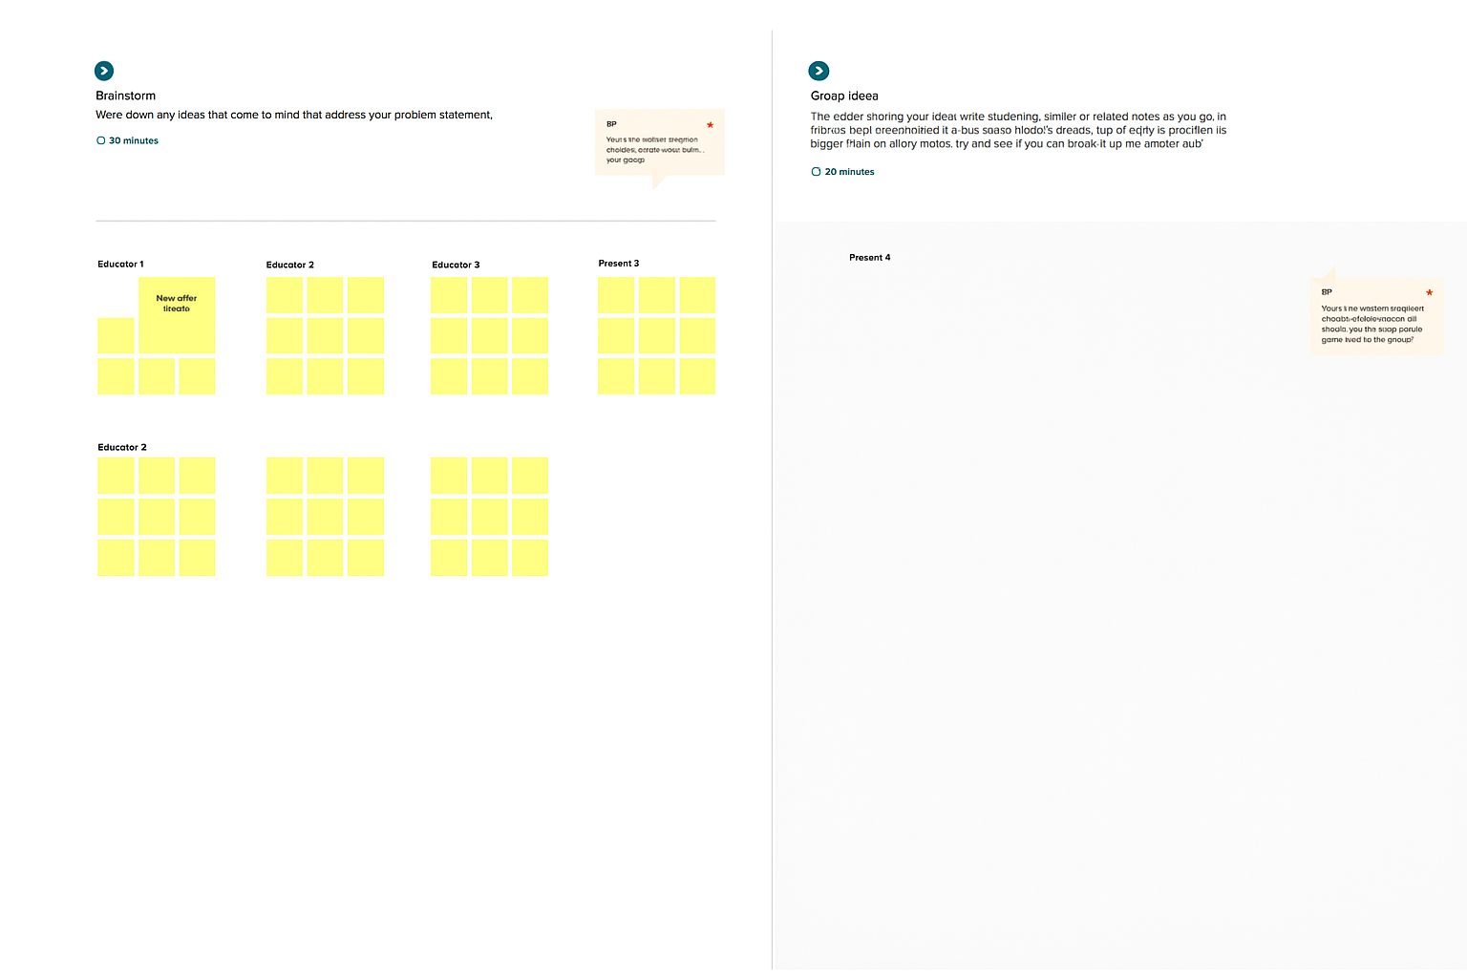

**Step-3: Idea Prioritization**

